SETTING UP BUDGETS
Attached is a sample of how the excel spreadsheet must be setup to import into Advanced Software. Must have periods set up with all 13 periods filled in, even if you do not use 13 periods. The heading should not be on the spreadsheet, it is there in the sample to let you know what the columns are. The excel spreadsheet needs to be saved as a .csv file before importing.

To import the figures into Advanced Software, you will go to the GF6 menu option and type in the location of the file.
See below. When finished processing, the budgets will then be filled into the current year budget column in the account file.

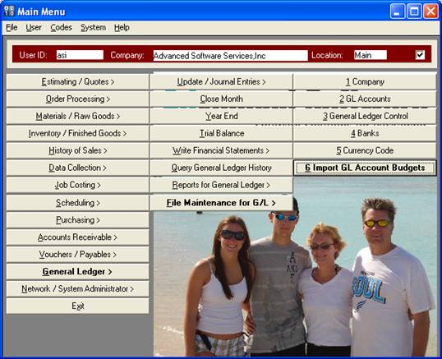

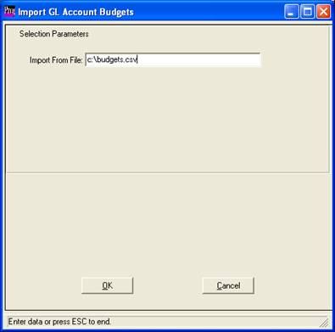
Must be a .csv file

To enter budgets manually, go to the GL Accounts File GF2. Use the update button and then fill in each periods budget amount into the current year budget column for each period. Save and then go to next account number.
